Advanced Database Training
2026
Vaishnavi Kamthe

Assignment 4a

Question
Create a trigger on a table created from Ecommerce_data_cleaned.csv. If any new row is inserted in the table, or any existing row is deleted or updated, the trigger should get activated. Once activated, it should insert a new row into the "audit_logs" table. The "audit_logs" tables should contain information such as :
1. The user who performed the operation.
2. The operation that was performed.
3. The table on which the operation was performed
4. The timestamp at which operation was performed.
Test your logic by adding a few rows to the table or making some updates and deletes to the table.
DATA :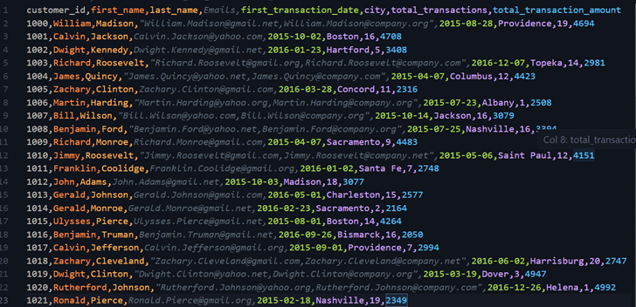
Imported the Data to MySQL:
Used the Table Data Import Wizard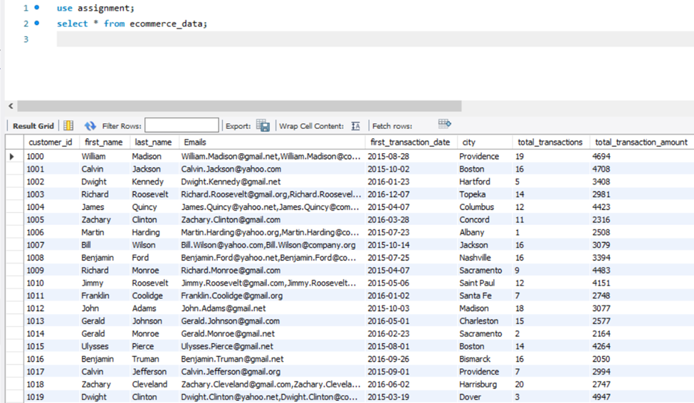
Created the table audit_logs: 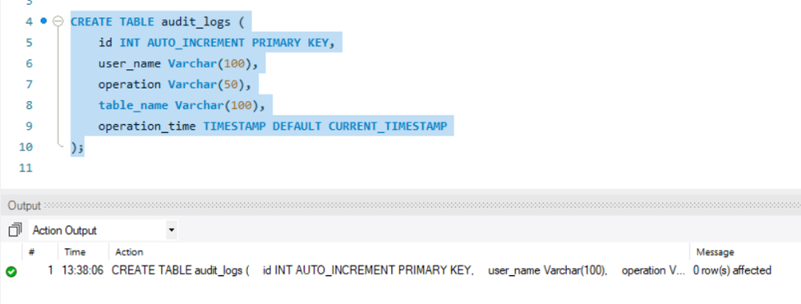
Created Insert Trigger : 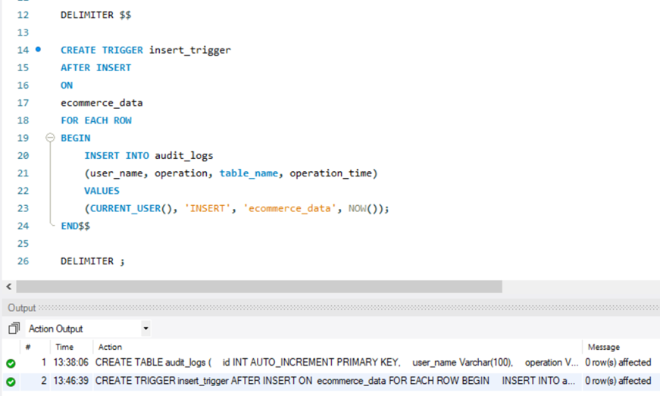
Created Update Trigger : 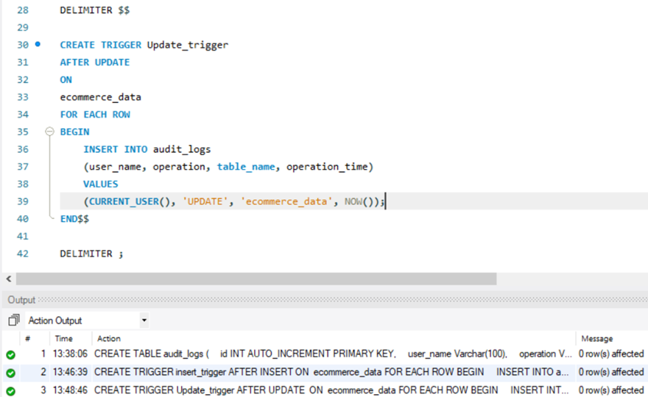
Created Delete Trigger :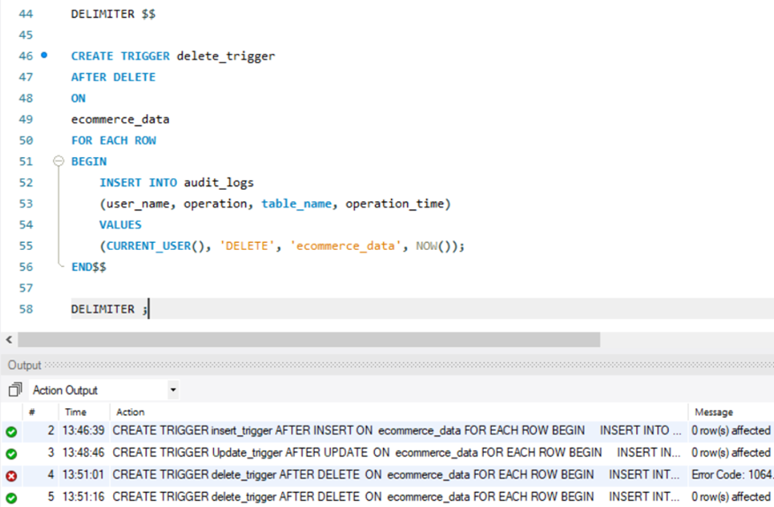
Test Cases
Insert Operation : 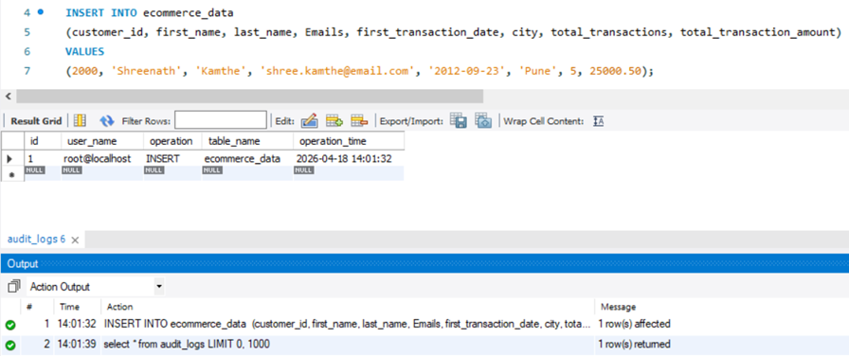
Update Operation : 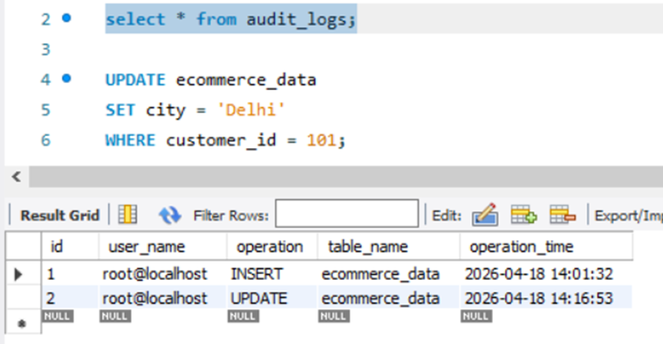
Delete Operation: